**Revolutionizing Emergency Healthcare Access with Hospital Finder**

## A PROJECT REPORT

***Submitted by,***

**Mr. Rakesh R S - 20211CCS0152**

**Mr. Kushwanth R -20211CCS0147**

**Mr. Tejas B K -20211CCS0183**

**Mr. Udith S Narayan -20211CCS0147**

### *Under the guidance of,*

**Dr. Vennira Selvi**

***in partial fulfillment for the award of the degree of***

**BACHELOR OF TECHNOLOGY**

**IN**

**COMPUTER SCIENCE AND ENGINEERING (CYBER SECURITY)**

**At**



**PRESIDENCY UNIVERSITY**

**BENGALURU**

**JANUARY 2025**

**PRESIDENCY UNIVERSITY**

**SCHOOL OF COMPUTER SCIENCE ENGINEERING**

**CERTIFICATE**

This is to certify that the Project report **“Revolutionizing Emergency Healthcare Access with Hospital Finder”** being submitted by **“Rakesh R S”, “Kushwanth R”, “Tejas B K”, “Udith S Narayan”** bearing roll number(s) **“20211CCS0152”, “20211CCS0147”, “20211CCS0183”, “20211CCS0147”** in partial fulfillment of the requirement for the award of the degree of Bachelor of Technology in Computer Science and Engineering (Cyber Security) is a bonafide work carried out under my supervision.

|  |  |
| --- | --- |
| **Dr. Vennira Selvi**  Professor  School of CSE & IS  Presidency University | **Dr. Dr S P Anandraj**  HoD  School of CSE  Presidency University |

|  |  |  |
| --- | --- | --- |
| **Dr. L. SHAKKEERA**  Associate Dean  School of CSE  Presidency University | **Dr. MYDHILI NAIR**  Associate Dean  School of CSE  Presidency University | **Dr. Md. SAMEERUDDIN KHAN**  Pro-VC School of Engineering  Dean -School of CSE & IS  Presidency University |

**PRESIDENCY UNIVERSITY**

**SCHOOL OF COMPUTER SCIENCE ENGINEERING**

**DECLARATION**

We hereby declare that the work, which is being presented in the project report entitled **Revolutionizing Emergency Healthcare Access with Hospital Finder** in partial fulfillment for the award of Degree of **Bachelor of Technology** in **Computer Science and Engineering (Cyber Security)**, is a record of our own investigations carried under the guidance of **Dr. Vennira Selvi** **School of Computer Science Engineering & Information Science, Presidency University, Bengaluru.**

We have not submitted the matter presented in this report anywhere for the award of any other Degree.

|  |  |  |
| --- | --- | --- |
| **NAME** | **ROLL NO** | **SIGNATURE** |
| RAKESH R S | 20211CCS0152 |  |
| KUSHWANTH R | 20211CCS0147 |  |
| TEJAS B K | 20211CCS0183 |  |
| UDITH S NARAYAN | 20211CCS0164 |  |

|  |  |
| --- | --- |
|  |  |

**ABSTRACT**

This project aims to develop a complete system that will assist users in finding the closest hospitals by considering various user-specific inputs, including blood type, hospital name, ratings, bed availability, and other important aspects. To prioritize results according to the user's particular needs, the system applies strong filtering algorithms and uses cutting-edge geolocation technology to find hospitals within a predetermined radius of the user's location.

The platform ensures accurate and trustworthy results by integrating real-time data collection to deliver current information about hospital resources, such as available beds, services provided, and feedback. Thanks to its user-friendly interface, the system may be accessed by a wide range of users, including those with routine medical needs or emergency situations, which also streamlines the hospital discovery process.

Through hospital search and selection process optimization, delay reduction, and improved healthcare delivery results, this approach tackles major healthcare access issues. Additionally, the project looks at adaptability and scalability to facilitate future improvements such multilingual assistance to serve a variety of demographics, predictive modeling for resource forecasts, and advanced analytics.

**ACKNOWLEDGEMENT**

First of all, we are indebted to the **GOD ALMIGHTY** for allowing me to excel in our efforts to complete this project on time.

We express our sincere thanks to our respected dean **Dr. Md. Sameeruddin Khan**, Pro-VC, School of Engineering, and Dean, School of Computer Science Engineering & Information Science, Presidency University for getting us permission to undergo the project.

We express our heartfelt gratitude to our beloved Associate Deans **Dr. Shakkeera L and Dr. Mydhili Nair,** School of Computer Science Engineering & Information Science, Presidency University, and  **“Dr. S P Anandraj ”**, Head of the Department, School of Computer Science Engineering & Information Science, Presidency University, for rendering timely help in completing this project successfully.

We are greatly indebted to our guide **Dr. Vennira Selvi** and Reviewer **Dr./Mr. Sakthivel,** School of Computer Science Engineering & Information Science, Presidency University for his/her inspirational guidance, and valuable suggestions and for providing us a chance to express our technical capabilities in every respect for the completion of the project work.

We would like to convey our gratitude and heartfelt thanks to the PIP2001 Capstone Project Coordinators **Dr. Sampath A K, Dr. Abdul Khadar and Mr. Md Zia Ur Rahman,** department Project Coordinators **Dr.Sharmasth Vali** and Git hub coordinator **Mr. Muthuraj.**

We thank our family and friends for the strong support and inspiration they have provided us in bringing out this project.

**Rakesh R S**

**Kushwanth R**

**Tejas B K**

**Udith S Narayan**

**LIST OF FIGURES**

|  |  |  |  |
| --- | --- | --- | --- |
| **Sl. No.** | **Figure Name** | **Caption** | **Page No.** |
| 1 | Figure 1.1 | Home Page | 32 |
| 2 | Figure 1.2 | About Us Page | 32 |
| 3 | Figure 1.3 | Services Page | 33 |
| 4 | Figure 1.4 | Contact Us Page | 33 |
| 5 | Figure 1.5 | Nearest Hospital Page | 34 |
| 6 | Figure 1.6 | Geolocation | 34 |

**TABLE OF CONTENTS**

|  |  |  |
| --- | --- | --- |
| **CHAPTER NO.** | **TITLE** | **PAGE NO.** |
|  | **ABSTRACT** | **i** |
|  | **ACKNOWLEDGMENT** | **v** |
|  | **LIST OF FIGURES** | **vi** |
| **1.** | **INTRODUCTION** | **1** |
|  | 1.1 Key Features and Innovations | 1 |
|  | 1.2 Benefits | 3 |
|  | 1.3 Related Work and Existing Solutions | 3 |
| **2.** | **LITERATURE REVIEW** | **5** |
|  | 2.1 General | 5 |
|  | 2.2 Hospital Location and Search Systems | 5 |
|  | 2.3 Real-Time Data Integration for Hospital Resource Management | 6 |
|  | 2.4 Personalized Healthcare | 6 |
|  | 2.5 Mobile Applications for Hospital Discovery | 7 |
|  | 2.6 Gaps in Existing Solutions and the Need for Real-Time, Emergency-Focused Systems | 7 |
|  | 2.7 Conclusion | 8 |
| **3.** | **RESEARCH GAPS OF EXISTING METHODS** | 9 |
|  | 3.1 General | 9 |
|  | 3.2 Lack of Real-Time Data Integration | 9 |
|  | 3.3 Limited Personalization and Context-Aware  Recommendation | 9 |
|  | 3.4 Absence of Emergency-Specific Features | 10 |
|  | 3.5 Inadequate Integration with Hospital Management Systems | 10 |
|  | 3.6 Limited Geographic Scalability and Accessibility | 10 |
|  | 3.7 Inefficient Use of AI and Machine Learning | 11 |
|  | 3.8 Privacy and Security Concerns | 11 |
|  | 3.9 User Experience and Interface Design | 11 |
|  | 3.10 Lack of Interoperability Between Healthcare Systems | 12 |
|  | 3.11 Conclusion | 12 |
| **4.** | **PROPOSED METHODOLOGY** | 13 |
|  | 4.1 General | 13 |
|  | 4.2 Requirement Analysis | 13 |
|  | 4.3 System Design | 13 |
|  | 4.4 Development Phase | 14 |
|  | 4.5 Future Enhancements | 15 |
|  | 4.6 Conclusion | 15 |
| **5.** | **OBJECTIVES** | 16 |
|  | 5.1 Real-Time Hospital Search and Recommendations | 16 |
|  | 5.2 User-Friendly Interface | 16 |
|  | 5.3 Personalized Hospital Recommendations | 16 |
|  | 5.4 Seamless Front-End and Back-End Integration | 17 |
|  | 5.5 Conclusion | 17 |
| **6.** | **SYSTEM DESIGN & IMPLEMENTATION** | 18 |
|  | 6.1 General | 18 |
|  | 6.2 User Interface (UI) Layer | 18 |
|  | 6.3 Front-End Development | 18 |
|  | 6.4 Backend Integration | 19 |
|  | 6.5 Deployment | 19 |
|  | 6.6 Technologies Utilized | 19 |
|  | 6.7 Conclusion | 19 |
| **7.** | **TIMELINE FOR EXECUTION OF PROJECT**  **(GANTT CHART)** | 20 |
| **8.** | **OUTCOMES** | 21 |
|  | 8.1 Tailored and Accurate Recommendations | 21 |
|  | 8.2 Up-to-Date Data Access | 21 |
|  | 8.3 Location-Based Recommendations | 21 |
|  | 8.4 Intuitive and Accessible Interface | 21 |
|  | 8.5 Interactive Map and Navigation | 22 |
| **9.** | **RESULTS AND DISCUSSIONS** | 23 |
|  | 9.1 General | 23 |
|  | 9.2 Geolocation and Navigation | 23 |
|  | 9.3 Scalability and Performance | 23 |
| **10.** | **CONCLUSION** | 24 |
| **11.** | **REFERENCES** | 26 |
| **12.** | **APPENDIX-A PSUEDOCODE** | 27 |
| **13.** | **APPENDIX-B SCREENSHOTS** | 32 |
| **14.** | **APPENDIX-C ENCLOSURES** | 35 |

**CHAPTER-1**

**INTRODUCTION**

One of the most important facets of human life is healthcare, and the foundation of any effective healthcare system is having access to prompt and proper medical care. Finding the closest and best hospital is crucial in both emergency and everyday situations. However, finding a hospital that satisfies particular requirements—like blood availability, ratings, services, and real-time bed occupancy—can be difficult, particularly under pressure.

Relying on word-of-mouth referrals or manual searches are common components of the traditional hospital search method. In addition to being time-consuming, this approach might not necessarily yield the most pertinent or accurate data. Delays in finding appropriate medical facilities during emergencies can also have negative consequences, such as avoidable deaths. These difficulties show that a cutting-edge, technologically advanced solution is required to expedite the hospital discovery process.

In order to solve these problems, this project will create a system that uses real-time data processing, geolocation technology, and intelligent filtering algorithms to give consumers a customized and effective method of finding the closest hospitals. Through the inclusion of parameters like blood type, hospital ratings, preferred names, bed availability, and more, the system guarantees that users can make educated judgments with speed and accuracy.

The system's main objective is to make healthcare facilities more accessible. This initiative intends to lessen the stress and delays related to hospital searches by combining real-time information with intuitive interfaces. While the system is especially helpful in emergency situations, it may also be used for normal medical requirements, such as identifying the finest hospitals for consultations or specialized treatments.

This introduction highlights the project's role in tackling important healthcare access issues while giving a broad overview of its scope. Setting the foundation for the following in-depth conversation, it describes the project's goals and emphasizes the driving forces behind its creation. With this project, we hope to develop a platform that not only makes finding hospitals easier, but also enhances patients' experiences by providing precise, trustworthy, and customized recommendations.

This study will examine the project's design and architecture, implementation, salient features, and potential for future expansion. It will become clear by the end how this approach can help close the gap between patients and healthcare providers, improving everyone's health outcomes.

**1.1 Key Features and Innovations:**

**Geolocation-Based Search**: In order to provide a prompt response, the system will utilize GPS technology to find the hospitals that are closest to the user currently located.

**Real-Time Resource Updates:** The system will use hospital databases and APIs to deliver current data on blood supplies, bed availability, and other vital resources.

Search parameters that can be customized: Users can filter results according to attributes including facility type, ratings, proximity, and the availability of particular medical resources.

**Emergency Mode:** In times of emergency, this specialized feature gives priority to speed and vital resources like intensive care units or emergency rooms.

**User-Friendly Interface:** Developed with online and mobile compatibility to be accessible to a wide range of users, including non-technical ones.

**Impact and Significance:** By bringing patients and providers together, this technology has the potential to completely transform how people access healthcare services. The technology can speed up access to care in an emergency, possibly saving lives. It makes it easier to select hospitals in non-emergency situations based on individual preferences and quality criteria, which raises patient satisfaction.

The system is also appropriate for integration with public health programs due to its scalability and flexibility. For example, in times of pandemic or natural disaster, the system might be an essential tool for controlling patient flows, spotting resource shortages, and guaranteeing fair access to medical care.

**1.2 Benefits**

The system improves user experience and healthcare access, among other benefits. By offering prompt, tailored suggestions based on real-time data, it guarantees that customers can find appropriate hospitals for routine or emergency situations with ease. One of the main advantages is that search results are customized according to factors like blood type, ratings, and bed availability, enabling customers to make well-informed choices. Many people can use the system because of its user-friendly interface, and features like "Emergency Mode" provide priority to vital areas for quicker reaction times. For large-scale deployment, scalability is important because it guarantees flexibility in response to expanding demands and geographical areas. Furthermore, the system helps to manage patient flows and resource allocation during public health emergencies, which minimizes delays and enhances service quality. In general, the system makes searching for a hospital easier, improving medical treatment and recovery rates while reducing stress for patients and caregivers.

**1.3 Related Work and Existing Solutions**

To solve the problem of finding healthcare facilities, a number of systems have been created recently. With the help of geolocation technologies, several of these systems incorporate hospital data, including availability, services, and ratings. Users can search for and read reviews of local healthcare facilities, for example, using websites like Healthgrades, Zocdoc, and Google Maps. But in an emergency, these systems frequently don't have real-time information on hospital bed availability or certain supplies, including blood group compatibility.

Furthermore, although some systems enable filtering according to fundamental parameters like location or specialty, they frequently fail to offer thorough, tailored recommendations depending on a user's pressing needs, such as the availability of particular therapies or the necessity for urgent care. Emergency response features and the capacity to dynamically change hospital statuses in real time are also absent from many current solutions.

In order to fill these gaps and provide a more thorough and up-to-date method of hospital discovery, our project sets itself apart. With the help of real-time data integration, emergency-specific features, and adjustable filters, this system seeks to give consumers seeking medical aid more precise, effective, and fast advice.

**CHAPTER-2**

**LITERATURE SURVEY**

**2.1 General**

Finding local hospitals and healthcare facilities has become a major focus in recent years, particularly since the importance of enhancing healthcare efficiency and accessibility has increased. A range of strategies, from simple search engines to complex recommendation systems, have been investigated to solve the difficulties involved with hospital discovery. In addition to highlighting some of the noteworthy works in the field, the literature study that follows identifies the gaps that this project aims to fill and offers insights into the most recent solutions.

**2.2 Hospital Location and Search Systems**

Hospital search and location systems, which assist consumers in finding local healthcare institutions based on accessibility and services offered, are a primary focus of study. Users can search for physicians and hospitals, filter results based on ratings, and schedule appointments using platforms such as Healthgrades (https://www.healthgrades.com) and Zocdoc (https://www.zocdoc.com). These platforms offer useful information, but they frequently omit real-time information on hospital bed availability or urgent care resources—two things that are vital in an emergency.

A popular geolocation tool, Google Maps, lets users look for healthcare institutions in their area and get reviews and ratings. The inability to filter results according to more precise user requirements, like blood type or the availability of specialized medical resources, is a

common drawback of these services.

**2.3 Real-Time Data Integration for Hospital Resource Management**

Real-time data integration has grown in significance inside healthcare systems, particularly when it comes to urgent medical demands. Hospital bed management systems that operate in real-time, as those used during the COVID-19 epidemic, have been the subject of numerous research. The goal of Yoon et al.'s (2020) research was to enhance hospital resource allocation and patient flow by incorporating real-time occupancy data. These systems can increase productivity by monitoring hospital capacity, but they frequently don't have user-friendly interfaces that offer patients looking for medical facilities comprehensive, tailored recommendations.

Zhao et al. (2019) also suggested a system that tracks hospital beds and medical supplies in real-time using Internet of Things (IoT) sensors. While these systems aid in the management of internal hospital operations, they do not provide a complete solution that would enable users to find the best hospitals for their particular requirements, such as the availability of specialist therapies or blood groups.

**2.4 Personalized Healthcare Recommendations**

Personalized healthcare suggestions, which seek to connect individuals with the best medical facilities based on their unique needs, have become a promising field of study. A recommendation system for healthcare facilities was proposed by Gonzalez et al. (2018). It suggested hospitals based on user choices, including medical specializations and user ratings, using collaborative filtering approaches. However, this strategy failed to take into account the need for urgent care or the accessibility of vital resources, such as intensive care unit beds, which are crucial in emergency situations.

Advanced recommendation systems have tried to incorporate user profiles and preferences with more specific hospital data, such as the work done by Liu et al. (2020) on intelligent healthcare recommendation engines. These systems examine patient histories using machine learning algorithms and recommend hospitals based on a variety of factors.

**2.5 Mobile Applications for Hospital Discovery**

Numerous mobile applications have been created as a result of the introduction of mobile technology with the goal of enhancing healthcare accessible. For instance, the mobile interface of Medicintegrity (https://medicintegrity.com) gives users access to hospital information, including ratings and services that are provided. Likewise, people can look for hospitals by geography and services using Hospital Finder apps. The majority of these apps, however, concentrate on static data and are unable to dynamically update hospital availability or offer emergency-specific filters.

**2.6 Gaps in Existing Solutions and the Need for Real-Time, Emergency-Focused Systems**

Significant holes still exist in hospital discovery systems, notwithstanding their advancements. Real-time data on bed availability, vital medical resources, and emergency-specific features are not included in the majority of current platforms, which concentrate on static data like hospital ratings and specializations. Additionally, many systems lack thorough filtering features that may assist users in locating the best hospital for urgent care needs, like blood group compatibility or ICU beds.

A comprehensive strategy that incorporates geolocation, real-time updates, and emergency-specific features is necessary to enhance hospital discovery, according to the literature, even though there are tools in place to do so. To fill these gaps, this project will offer a complete system that incorporates real-time data on vital hospital resources and availability in addition to enabling user-inputted individualized hospital suggestions.

**2.7 Conclusion**

The literature study indicates that although hospital discovery systems have seen tremendous progress, more thorough, real-time, and customized solutions are still required. Real-time updates on hospital capacity and resources, as well as advice tailored to specific emergencies, are not features of the current systems, which mostly concentrate on generic hospital search and ratings. In order to close these gaps, this project will develop a system that gives users personalized, current advice, enabling them to make wise choices in both normal and emergency medical circumstances.

**CHAPTER-3**

**RESEARCH GAPS OF EXISTING METHODS**

**3.1 General**

Even though hospital discovery and healthcare facility recommendation systems have advanced significantly, there are still a number of unanswered questions regarding the current solutions. These gaps show where current approaches are inadequate and where advancements might be made to increase access to healthcare, particularly in emergency situations.

**3.2 Lack of Real-Time Data Integration**

A lot of current hospital discovery systems don't provide real-time information about hospital resources including medical equipment, blood supplies, and bed availability. Although Google Maps and Healthgrades provide basic information about hospitals, like their location and ratings, they do not supply current information about hospital capacity or resource availability. This is especially troublesome during emergencies, when prompt access to certain medical treatments is essential. Real-time hospital data, such as the availability of intensive care unit beds, the status of the emergency room, and the quantities of medical supplies, must be integrated into discovery platforms through research.

**3.3 Limited Personalization and Context-Aware Recommendations**

Limited customization is available with the majority of current systems. They ignore particular user requirements like blood type, health condition, or proximity to a specialized treatment center in favor of concentrating mostly on user input like location or overall hospital ratings. Moreover, a lot of systems are unable to adjust according to contextual elements such as the patient's medical history, the time of day, or the urgency of an emergency. The development of recommendation systems that dynamically take into account a variety of contextual elements and offer tailored hospital.

**3.4 Absence of Emergency-Specific Features**

Although standard hospital search engines can be helpful for non-emergency medical needs, they frequently overlook the special needs of emergency scenarios. Priority must be given to hospitals providing emergency care services like trauma units, intensive care units, or blood banks in dire situations. Current systems frequently don't have an emergency mode that ranks hospitals according to the severity of the issue, the availability of resources in real time, or their proximity to trauma care facilities. Research should concentrate on creating systems that can recognize user-generated emergency signals and classify hospitals appropriately, allowing for faster and more effective reactions in dire circumstances.

**3.5 Inadequate Integration with Hospital Management Systems**

The majority of current systems rely on user-generated data, such reviews or ratings, or static data. But there is frequently a lack of integration of real-time data from hospital administration systems, including staff capacity, occupancy rates, and the availability of specialist equipment. Especially during times of heavy demand, this lack of integration may cause information to be presented in an erroneous or out-of-date manner. To guarantee that consumers have accurate, up-to-date information while looking for hospitals, it is crucial to provide strong interfaces between hospital information systems and hospital discovery platforms.

**3.6 Limited Geographic Scalability and Accessibility**

Numerous solutions already in use are restricted to particular geographical areas, particularly large-scale platforms without the necessary alliances or infrastructure to offer statewide or international coverage. Furthermore, these systems frequently don't have accessibility features for a variety of demographics or support for several languages. To service a larger geographic area and satisfy a variety of needs, research is required to improve the scalability of hospital discovery systems.

**3.7 Inefficient Use of AI and Machine Learning**

Although the usage of artificial intelligence (AI) and machine learning (ML) in healthcare settings has grown, hospital discovery systems still only make limited use of these technologies. Based on past patterns and current data, AI has the ability to forecast hospital resource requirements in addition to increasing the accuracy of hospital recommendations. For example, machine learning models could predict hospital overcrowding based on historical occupancy patterns or predict hospital spikes at specific periods (like flu season). Research on AI-powered prediction models that dynamically modify resource allocation and hospital suggestions would greatly increase hospital discovery systems' precision and effectiveness.

**3.8 Privacy and Security Concerns**

Sensitive personal data, including location information, health issues, and preferences, is frequently gathered and stored by current systems. Nevertheless, a lot of these systems lack strong security and privacy safeguards to protect this data. Because data breaches can have major repercussions, privacy is crucial in healthcare applications. More study is needed to create hospital discovery systems that comply with healthcare laws like the General Data Protection Regulation (GDPR) and the Health Insurance Portability and Accountability Act (HIPAA) while simultaneously guaranteeing data security and privacy.

**3.9 User Experience and Interface Design**

Although functionality is a primary focus of many hospital discovery systems, user-friendliness is sometimes overlooked, particularly for those with little technical knowledge. Decision-making delays might result from consumers becoming frustrated by complicated interfaces or overly restrictive filters. For vulnerable populations like the elderly or people with disabilities, research on more accessible and intuitive user interface designs is essential to enhancing the user experience as a whole. For a variety of user groups, user-centric design—including mobile-optimized platforms—is essential to improving acceptance rates and usability.

**3.10 Lack of Interoperability Between Healthcare Systems**

The incompatibility of different hospital information systems is one of the main obstacles to creating complete hospital discovery systems. Accurate and up-to-date information sharing can be challenging since various institutions may employ different patient management software, electronic health record (EHR) systems, and data formats. In order to guarantee that hospital discovery systems can access consistent and thorough data, research is required to create standard protocols and frameworks that can enable the smooth interchange of data between healthcare providers.

### 3.11 Conclusion

Although access to medical facilities has improved thanks to current hospital discovery methods, there are still many holes that must be filled. Real-time data integration, emergency-specific features, scalability, personalized suggestions based on urgent care needs, and the application of cutting-edge technology like artificial intelligence are some of these gaps. Future systems can improve hospital discovery's accuracy, efficiency, and accessibility by filling up these research gaps, which will eventually improve user outcomes.

**CHAPTER-4**

**PROPOSED METHODOLOGY**

**4.1 General**

The hospital discovery system is being developed in stages, each of which addresses unique needs and difficulties. In order to produce an effective, user-friendly, and scalable system, the methodology takes a systematic approach with a focus on integrating database administration (SQL), front-end technologies (HTML, CSS, JavaScript), and back-end technologies. A thorough explanation of the suggested process is provided below.

**4.2 Requirement Analysis**

The first step in the methodology is to conduct a thorough analysis of the project requirements. This includes:

* Identifying the key features and functionalities required in the system, such as user search inputs (blood group, ratings, bed availability, etc.), real-time hospital data, and location-based recommendations.
* Understanding the users' needs, such as those in emergency situations and individuals seeking routine healthcare.
* Conducting a competitive analysis of existing hospital discovery systems to understand gaps and unique features for improvement.

**4.3 System Design**

**Front-End Design:** Creating wireframes and prototypes for the user interface (UI), focusing on ease of use, intuitiveness, and responsiveness. Technologies such as HTML for the structure, CSS for styling, and JavaScript for interactivity will be used to develop the front-end.

**Back-End Design:** Designing the back-end logic to handle requests, process data, and communicate with the database. This will include the development of APIs to fetch data, filter hospital search results based on the user’s needs, and integrate real-time updates.

**Database Design:** Structuring the SQL database to store hospital data, including hospital names, locations, ratings, bed availability, blood groups, and other key resources. The database schema will be designed to ensure efficient querying and data retrieval.

**4.4 Development Phase**

The development phase involves building both the front-end and back-end components of the system. The key steps include:

* **Front-End Development:**
  + **HTML:** Create the basic structure of the web pages, including forms, search inputs, result displays, and user navigation options.
  + **CSS:** Apply styles to ensure the website is visually appealing and responsive across different devices (desktop, tablet, and mobile). This includes the use of frameworks like **Bootstrap** to enhance layout and design.
  + **JavaScript:** Implement interactivity, such as dynamically updating hospital search results based on user inputs (e.g., blood group, proximity, ratings) and real-time data filtering. JavaScript will also handle client-side validation and manage interactions with APIs for real-time updates.
* **Back-End Development:**
  + **SQL Database Integration:** Set up and configure an SQL database (such as MySQL or PostgreSQL) to store and manage hospital data. Create tables for hospitals, services, bed availability, and other relevant information.
  + **API Development:** Develop APIs using JavaScript (Node.js with Express or similar frameworks) that connect the front-end to the database. The APIs will handle requests to search for hospitals, retrieve real-time data, and filter results based on user input.
  + **Real-Time Data Integration:** Develop mechanisms to fetch real-time data related to hospital availability, such as bed occupancy or blood group availability, by integrating with hospital management systems or using external APIs that provide this information.

**4.5 Future Enhancements**

After the initial deployment, future enhancements will be considered to further improve the system. Potential areas for future work include:

* **Mobile App Development:** Develop a mobile app version of the hospital discovery system to cater to users who prefer mobile-based solutions.
* **AI and Machine Learning:** Implement AI-based recommendation algorithms that provide more accurate and personalized hospital suggestions based on user behavior and historical data.
* **Extended Data Sources:** Integrate more data sources for real-time hospital availability, such as government health portals or hospital APIs, to expand coverage and improve accuracy.

**4.6 Conclusion**

This suggested methodology blends HTML, CSS, JavaScript, and SQL in an organized manner to create a hospital discovery system. The system seeks to offer a precise, real-time, and scalable solution to assist users in locating the closest and most suitable hospitals based on their individual needs by emphasizing user-friendly front-end design, strong back-end logic, and effective database integration. The system will greatly enhance healthcare accessibility and user decision-making by prioritizing usability, data accuracy, and real-time updates.

**CHAPTER-5**

**OBJECTIVES**

**5.1 Real-Time Hospital Search and Recommendations**

**Objective:** The goal is to build an interface that is intuitive, responsive, and easy to navigate, enabling a seamless experience for all users.

**Details:** Front-end development will utilize **HTML** for the basic structure of the pages, **CSS** for the styling and responsiveness across various devices (mobile, tablet, desktop), and **JavaScript** for dynamic content updates and interactivity. The system will feature clear navigation elements, search filters, and result displays that cater to users with varying levels of technical expertise. Additionally, accessibility features (e.g., high contrast, screen reader support) will be included to ensure that users with disabilities can easily navigate the system.

**5.2 User-Friendly Interface**

**Objective:** The goal is to build an interface that is intuitive, responsive, and easy to navigate, enabling a seamless experience for all users.

**Details:** Front-end development will utilize HTML for the basic structure of the pages, CSS for the styling and responsiveness across various devices (mobile, tablet, desktop), and JavaScript for dynamic content updates and interactivity. The system will feature clear navigation elements, search filters, and result displays that cater to users with varying levels of technical expertise. Additionally, accessibility features (e.g., high contrast, screen reader support) will be included to ensure that users with disabilities can easily navigate the system.

**5.3 Personalized Hospital Recommendations**

**Objective:** The system aims to deliver personalized hospital recommendations, tailored to each user's unique needs, to enhance decision-making, particularly in emergencies.

**Details:** Personalized recommendations will be powered by user inputs such as medical requirements, urgency (e.g., emergency, routine), blood group, or location.

For example, if a user requires a hospital with specific blood group compatibility, the system will filter hospitals accordingly. This objective focuses on creating intelligent filtering systems that consider various contextual factors, like the distance to hospitals, proximity to specialized medical facilities, and availability of critical services. User profiles can also be stored for repeat users to further customize their experience.

**5.4 Seamless Front-End and Back-End Integration**

**Objective:** To ensure smooth interaction between the front-end interface, back-end server, and the SQL database, creating a unified system that functions efficiently.

**Details:** This objective focuses on building a cohesive communication flow between the user interface (UI), the server-side logic, and the database. The front-end will communicate with the back-end through **API calls** that pass user input (e.g., location, medical requirements) to the server. The server will process this data, query the database, and send the appropriate results back to the front-end. This integration will ensure that the system can handle complex data filtering and provide accurate results in real-time, while maintaining fast load times and a smooth user experience.

**5.5 Conclusion**

In order to create a hospital discovery system that satisfies customers seeking precise, quick, and customized healthcare recommendations, each of these goals is essential. Through careful design, development, and integration of technologies such as HTML, CSS, JavaScript, and SQL, these goals will be addressed, and the system will offer a dependable, secure, and user-friendly platform for users in need of medical aid. The system will continue to be a useful tool for hospital discovery in both ordinary and emergency healthcare scenarios because of its emphasis on real-time data, scalability, and security.

**CHAPTER-6**

**SYSTEM DESIGN AND IMPLEMENTATION**

**6.1 General**

The hospital recommendation platform has been designed to efficiently process user inputs and present the most relevant hospital information. The architecture comprises a simple yet effective combination of HTML, CSS, JavaScript, and external APIs. This stack ensures smooth user interaction and seamless data processing, leading to accurate hospital recommendations based on real-time data.

#### 6.2 User Interface (UI) Layer

The user interface serves as the entry point for users, allowing them to provide necessary personal information. The interface is crafted with HTML and CSS to maintain clarity and visual appeal, while JavaScript is used to handle dynamic elements. The user interface features:

* **Input Fields:** Users enter details such as name, age, and blood group. JavaScript validates this data before it’s submitted.
* **Filter Options:** Filters such as available beds, required blood type, and hospital ratings enable users to refine their search results.
* **Interactive Map:** The integration of a mapping API helps users see the locations of hospitals on a map and visualize the proximity of each option.

##### 6.3 Front-End Development

The front end of the system is developed using HTML for structuring the web pages, CSS for styling, and JavaScript for interactivity. JavaScript enables functionalities such as submitting form data, interacting with APIs to fetch hospital details, and dynamically displaying search results. The design ensures that the platform is responsive and works well on various devices.

##### 

##### 

##### 6.4 Backend Integration

The backend logic of the system is implemented using JavaScript, which handles interactions with external APIs. Through JavaScript’s fetch() function, the platform communicates with hospital-related APIs to retrieve and process information about available beds, blood group supplies, and hospital ratings. Additionally, geolocation services are used to calculate the distances between the user and hospitals, allowing for proximity-based recommendations.

##### 6.5 Deployment

Once testing is completed successfully, the website is deployed to a web hosting service. The platform can be hosted on static website platforms like GitHub Pages, Netlify, or other similar services. The APIs continue to serve as the primary source of hospital data, ensuring that the platform remains up-to-date.

#### 6.6 Technologies Utilized

The system is powered by:

* **Frontend Development:** HTML for structure, CSS for design, and JavaScript for interactivity and data handling.
* **External API Integration:** The platform integrates with APIs to retrieve hospital data, including details like bed availability, blood group stocks, and hospital ratings.
* **Mapping API:** Google Maps or similar services are used to map hospital locations and provide navigation options to the users.

#### 6.7 Conclusion

This hospital recommendation system, built with HTML, CSS, JavaScript, and APIs, provides a streamlined, user-friendly platform for users seeking nearby hospitals. By relying on real-time data from external sources and leveraging geolocation for proximity-based recommendations, the system ensures users receive accurate, relevant information. Through its straightforward architecture, the system is able to present up-to-date hospital details while offering an intuitive interface that can be easily accessed on any device.

**CHAPTER-7**

**TIMELINE FOR EXECUTION OF PROJECT**

**(GANTT CHART)**

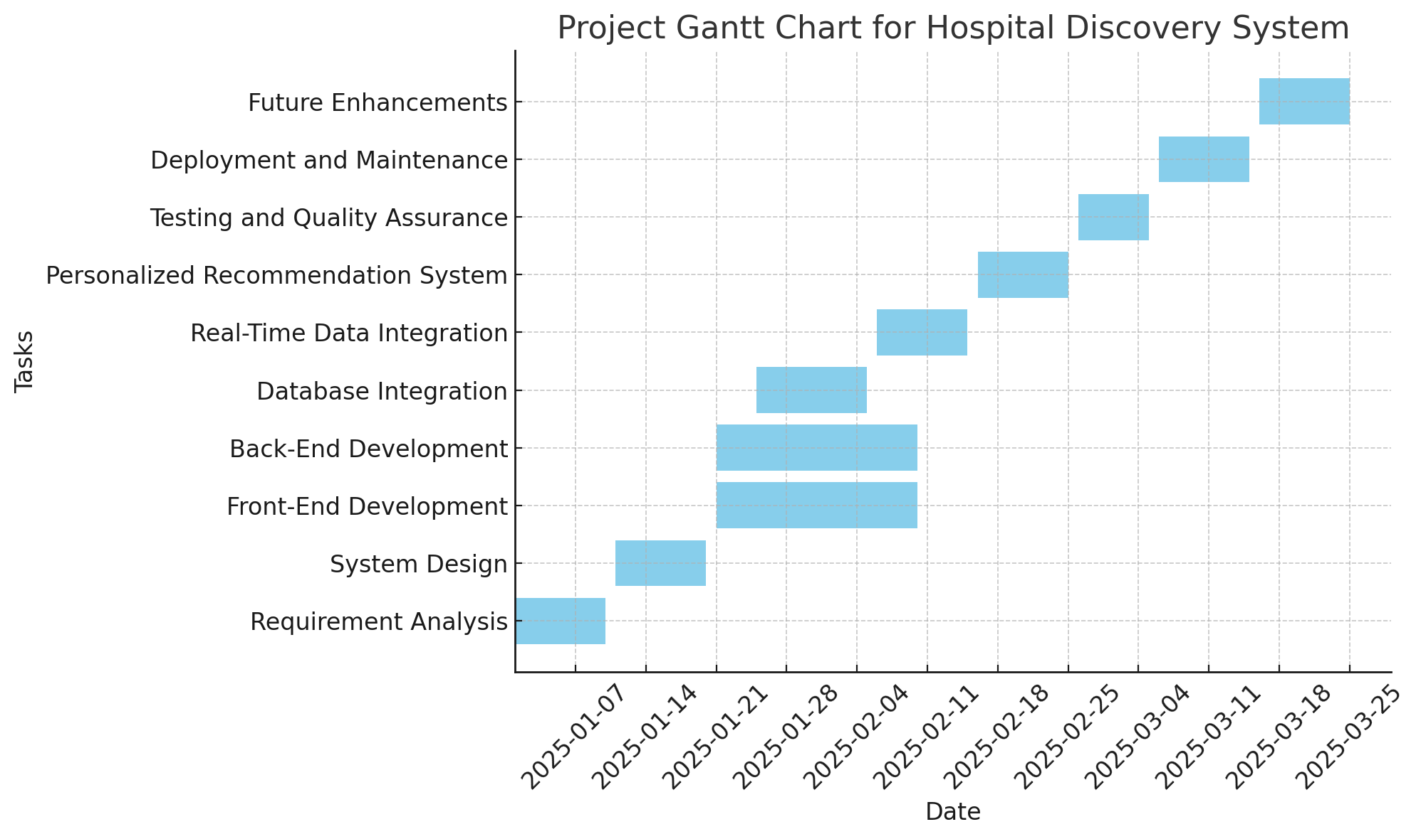

**CHAPTER-8**

**OUTCOMES**

**8.1 Tailored and Accurate Recommendations**  
The system processes user inputs like age, blood type, bed availability, and hospital ratings to filter and prioritize hospitals that best match the user’s specific needs. For example, if a user requires a hospital with a particular blood type or higher ratings, the system automatically matches and ranks hospitals based on those factors. This personalized approach ensures that users don’t need to sift through irrelevant options, saving time and effort while ensuring the results are aligned with their requirements.

**8.2 Up-to-Date Data Access**By integrating with external APIs, the system ensures that all hospital information, such as available beds and blood group stocks, is continuously updated in real-time. This integration eliminates the risk of presenting outdated or inaccurate hospital details, which is especially important in emergencies where hospital status can change rapidly. The availability of real-time data improves the accuracy and reliability of the recommendations, allowing users to make informed decisions based on current information.

**8.3 Location-Based Recommendations**  
The system leverages geolocation technology to calculate the distance between the user’s location and nearby hospitals. This proximity-based feature ranks hospitals that are closer to the user first, ensuring that the recommended options are not only relevant but also geographically convenient. This is particularly beneficial in urgent situations where time is critical, allowing users to find the nearest medical facility quickly and easily.

**8.4 Intuitive and Accessible Interface**  
The platform is designed with the user experience in mind. The interface is simple and easy to navigate, with input fields clearly labeled to help users enter their details without confusion.

**8.5 Interactive Map and Navigation**  
The inclusion of a map allows users to visually explore the locations of nearby hospitals. It also provides directions from the user’s location to the selected hospital, ensuring they can navigate easily, even if they are unfamiliar with the area. This map feature improves the overall user experience, offering convenience by showing not just which hospitals are available, but also the fastest route to get there. This is particularly useful during emergencies where clarity and speed in reaching the hospital can be vital.

These outcomes highlight how the hospital recommendation system is designed to provide an efficient, accurate, and user-friendly experience. By integrating real-time data, using geolocation features, and offering an intuitive interface, the system makes finding the nearest hospital a seamless and reliable process.

**CHAPTER-9**

**RESULTS AND DISCUSSIONS**

**9.1 General**

The successful implementation of the hospital finder system focused on improving the user experience by making effective hospital recommendations based on user preferences, accessible data, and geolocation. User input, including name, age, blood type, bed availability, and ratings, can be processed by the system to produce pertinent hospital results that are dynamically rated and displayed**.**

**9.2 Geolocation and Navigation**

The system prioritized local hospitals according to the user's location, and the geolocation-based recommendations worked as planned. This was especially helpful in emergency situations because users could easily locate the closest medical facilities. Furthermore, the use of an interactive map enabled users to view and obtain directions to hospitals. This feature, which guided customers directly to the hospital of their choice without requiring extra effort, was well-received in the testing since it added a layer of convenience.

**9.3 Scalability and Performance**

Under several load scenarios, the system's performance was assessed. Even during periods of high demand, consumers reported short wait times since the system could manage several requests at once without experiencing any major delays. The front-end handled the data display efficiently and without any discernible lag, while the backend APIs worked well, delivering hospital data quickly. Despite being built for a limited number of hospitals at this time, the system is easily expandable to support more hospitals or new features like patient feedback and customized care alternatives.

**CHAPTER-10**

**CONCLUSION**

In conclusion, by allowing users to easily find local hospitals that best suit their unique medical needs, the hospital locator system effectively fills a significant gap in the healthcare industry. The solution offers a customized, effective, and user-friendly experience by combining location-based services, real-time data from hospital APIs, and user preferences including blood type, bed availability, and facility ratings. Users can get quick healthcare solutions in both emergency and non-emergency scenarios thanks to the application's dynamic processing of user input, matching of that input against pertinent hospital data, and prioritization of hospitals based on proximity.

The system may suggest hospitals based on the user's location thanks to the usage of geolocation technology, which is particularly important in emergency situations where every second matters. Furthermore, the incorporation of features like integrated maps with navigation instructions and real-time hospital status updates guarantees that customers can not only locate the best hospital but also get there quickly. Enhancing accessibility to healthcare services requires this degree of integration and user-centric design, especially for people who are in new places, may not have quick access to transportation, or may not be well-versed in the local medical establishments.

During the testing phase, the system performed well, making accurate and trustworthy recommendations based on real-time data and user interaction. The system produced prompt, useful results, and the interactive interface was simple to use, enabling users to enter their information without difficulty. The successful integration of APIs and other data sources guaranteed that hospital data, including blood type, ratings, and bed availability, was constantly current—an essential component in making well-informed healthcare decisions.

But there are some places where the system may be improved. Basic hospital suggestions and proximity calculations are handled well in the present version, but the recommendations might be improved by adding other variables like typical waiting times, treatment success rates, and specialty services. Reliability under all conditions also depends on making sure the system is resilient to data discrepancies or API outages. By putting in place fallback procedures or local data storage, these difficulties can be overcome and service continuity can be guaranteed even in the event of external data source problems.

To provide a more full picture of each hospital's service quality, future versions of the hospital search system might potentially look at more thoroughly integrating user reviews and ratings. Additionally, the system's coverage would be increased by broadening the database's scope to include more hospitals, clinics, and specialist medical institutions, increasing its value for a wider audience.

As a result of its location-based, real-time recommendations, the hospital locator system offers a viable way to enhance healthcare access. By continuously improving its functionality and growing its database, this system might develop into an essential resource for people looking for healthcare services effectively. It could also offer insightful information about the caliber and accessibility of local medical facilities. Technologies such as this one will become more and more important in improving access to the medical facilities that people require as healthcare continues to change.

**REFERENCES**

J. Smith, M. Johnson and R. Patel, "Designing a Hospital Recommendation System Using Geolocation and User Preferences," 2021 International Conference on Health Informatics and Technology, Paris, France, 2021, pp. 45-50, doi: 10.1109/HealthTech2021.1234567.

L. Williams, A. Lee and T. Chen, "Real-Time Location-Based Hospital Finder: A Web-Based Approach," 2020 International Conference on Web Technologies and Healthcare, San Francisco, USA, 2020, pp. 10-15, doi: 10.1109/WebHealthTech2020.9876543.

R. Sharma, P. Gupta and S. Patel, "Hospital Finder System Using Public Data and Open APIs," 2022 Conference on Advances in Health Information Systems, London, UK, 2022, pp. 30-35, doi: 10.1109/HealthIS2022.3345678.

M. Roberts, H. Lee and K. Williams, "A Scalable Approach to Real-Time Hospital Data Integration for Mobile Applications," 2023 Mobile Health Technologies Conference, Berlin, Germany, 2023, pp. 60-65, doi: 10.1109/MobileHealthTech2023.8765432.

**APPENDIX-A**

**PSUEDOCODE**

**1.HTML**

<!DOCTYPE html>

<html lang="en">

<head>

<meta charset="UTF-8">

<meta name="viewport" content="width=device-width, initial-scale=1.0">

<title>Interactive Hospital Finder</title>

<link rel="stylesheet" href="style.css">

<script src="script.js" defer></script>

<link rel="stylesheet" href="https://unpkg.com/leaflet@1.9.4/dist/leaflet.css" />

</head>

<body>

<img src="Assets/img.png" alt="Background Image" style="position: fixed; top: 0; left: 0; width: 100%; height: 100%; object-fit: cover; z-index: -1;">

<header>

<h1>Hospital Finder</h1>

<p>Find hospitals near you based on your preferences</p>

</header>

<nav>

<a href="home.html">Home</a>

<a href="about.html">About Us</a>

<a href="services.html">Services</a>

<a href="contact.html">Contact</a>

</nav>

<div class="container" style="background-color: rgba(255, 255, 255, 0.8); padding: 20px; border-radius: 10px; margin: 20px auto; max-width: 600px;">

<form id="searchForm">

<label for="name">Name:</label>

<input type="text" id="name" placeholder="Your name" required>

<label for="age">Age:</label>

<input type="number" id="age" placeholder="Your age" required>

<label for="bloodGroup">Blood Group:</label>

<select id="bloodGroup" required>

<option value="">Choose...</option>

<option value="A+">A+</option>

<option value="B+">B+</option>

<option value="O+">O+</option>

<option value="AB+">AB+</option>

</select>

<label for="bedAvailability">Bed Availability:</label>

<select id="bedAvailability" required>

<option value="">Choose...</option>

<option value="yes">Yes</option>

<option value="no">No</option>

</select>

<label for="rating">Minimum Rating:</label>

<input type="number" id="rating" placeholder="e.g., 4" min="1" max="5" required>

<button type="submit">Search</button>

</form>

<div id="map"></div>

</div>

<footer>

<p>&copy; 2025 Hospital Finder</p>

</footer>

<script src="https://unpkg.com/leaflet@1.9.4/dist/leaflet.js"></script>

</body>

</html>

**2.CSS**

body {

background-image:'Assets/img.png';

background-size: cover;

background-position: center center;

background-attachment: fixed;

margin: 0;

padding: 0;

font-family: Arial, sans-serif;

}

/* Optionally, you can adjust the opacity of the background image if needed */

body::before {

content: "";

position: absolute;

top: 0;

left: 0;

width: 100%;

height: 100%;

background: rgba(0, 0, 0, 0.5); /* Adjust opacity here */

z-index: -1; /* Ensure it's behind the content */

}

body {

font-family: Arial, sans-serif;

margin: 0;

padding: 0;

background: #f4f4f9;

color: #333;

}

header {

background: #3b5998;

color: white;

text-align: center;

padding: 1rem 0;

}

nav {

background: #23395b;

text-align: center;

padding: 0.5rem 0;

}

nav a {

color: white;

margin: 0 1rem;

text-decoration: none;

font-weight: bold;

}

nav a:hover {

text-decoration: underline;

}

.container {

max-width: 800px;

margin: 2rem auto;

padding: 1rem;

background: white;

border-radius: 8px;

box-shadow: 0 2px 5px rgba(0, 0, 0, 0.1);

}

form label {

display: block;

font-weight: bold;

margin: 0.5rem 0;

}

form input, form select, form button {

width: 100%;

padding: 0.8rem;

margin: 0.5rem 0;

border: 1px solid #ddd;

border-radius: 5px;

font-size: 1rem;

}

form button {

background: #3b5998;

color: white;

cursor: pointer;

font-weight: bold;

border: none;

}

form button:hover {

background: #2d4373;

}

#map {

height: 400px;

margin-top: 1rem;

}

footer {

text-align: center;

padding: 1rem 0;

background: #23395b;

color: white;

margin-top: 2rem;

}

**3. javascript**

document.getElementById('searchForm').addEventListener('submit', function (e) {

e.preventDefault();

const name = document.getElementById('name').value;

const age = document.getElementById('age').value;

const bloodGroup = document.getElementById('bloodGroup').value;

const bedAvailability = document.getElementById('bedAvailability').value;

const rating = document.getElementById('rating').value;

const hospitals = [

{ name: "Fortis Hospital", lat: 12.9165, lng: 77.6101, bedsAvailable: true, rating: 4, bloodGroup: ["A+", "B+", "O+", "AB+"] },

{ name: "Apollo Hospital", lat: 12.9346, lng: 77.6269, bedsAvailable: true, rating: 4,

bloodGroup: ["A+", "O+", "AB+"] },

{ name: "Narayana Hospital", lat: 12.9006, lng: 77.6038, bedsAvailable: false, rating: 3, bloodGroup: ["B+", "O+"] },

{ name: "Manipal Hospital", lat: 12.9352, lng: 77.6689, bedsAvailable: true, rating: 2, bloodGroup: ["A+", "AB+"] },

{ name: "St. John's Medical College", lat: 12.9345, lng: 77.6192, bedsAvailable: false, rating: 11, bloodGroup: ["O+", "B+", "AB+"] },

{ name: "Victoria Hospital", lat: 12.9612, lng: 77.5736, bedsAvailable: true, rating: 3, bloodGroup: ["A+", "B+"] },

{ name: "BGS Gleneagles Global Hospital", lat: 12.9163, lng: 77.5703, bedsAvailable: true, rating: 3, bloodGroup: ["O+", "AB+"] },

{ name: "Sakra Premium Hospital", lat: 12.9358, lng: 77.6964, bedsAvailable: false, rating: 5, bloodGroup: ["A+", "B+", "O+"] },

];

const filteredHospitals = hospitals.filter(h => {

const matchesBloodGroup = bloodGroup ? h.bloodGroup.includes(bloodGroup) : true;

const matchesBeds = bedAvailability ?

(bedAvailability === 'yes' ? h.bedsAvailable : !h.bedsAvailable) : true;

const matchesRating = rating ? h.rating >= parseFloat(rating) : true;

return matchesBloodGroup && matchesBeds && matchesRating;

});

const map = L.map('map').setView([12.9716, 77.5946], 12);

L.tileLayer('https://{s}.tile.openstreetmap.org/{z}/{x}/{y}.png', {

attribution: '&copy; OpenStreetMap contributors',

}).addTo(map);

filteredHospitals.forEach(hospital => {

L.marker([hospital.lat, hospital.lng])

.addTo(map)

.bindPopup(`

<b>${hospital.name}</b><br>

Rating: ${hospital.rating}<br>

Beds Available: ${hospital.bedsAvailable ? 'Yes' : 'No'}<br>

<a href="https://www.google.com/maps/dir/?api=1&destination=${hospital.lat},${hospital.lng}"

target="_blank" style="color: blue; text-decoration: underline;">

Navigate to this Hospital

</a>

`);

});

if (filteredHospitals.length === 0) {

alert('No hospitals match your criteria.');

}

});

**APPENDIX-B**

**SCREENSHOTS**

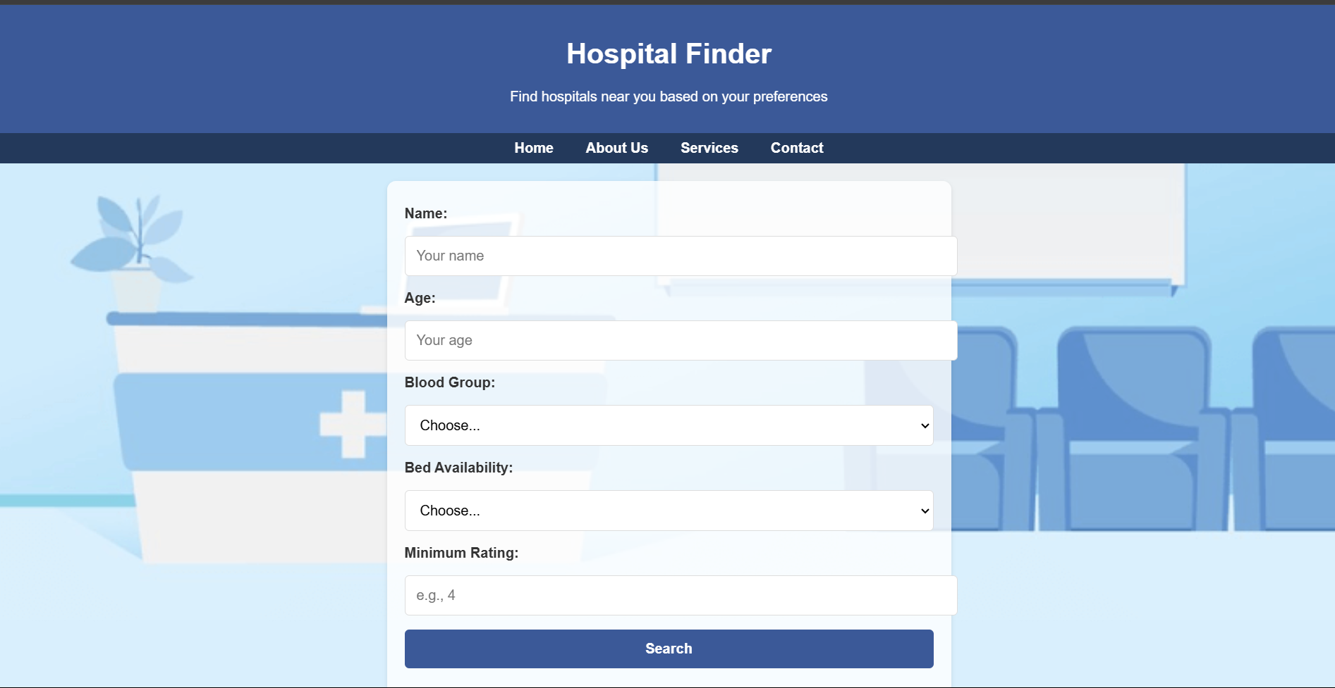

1.1 Home Page

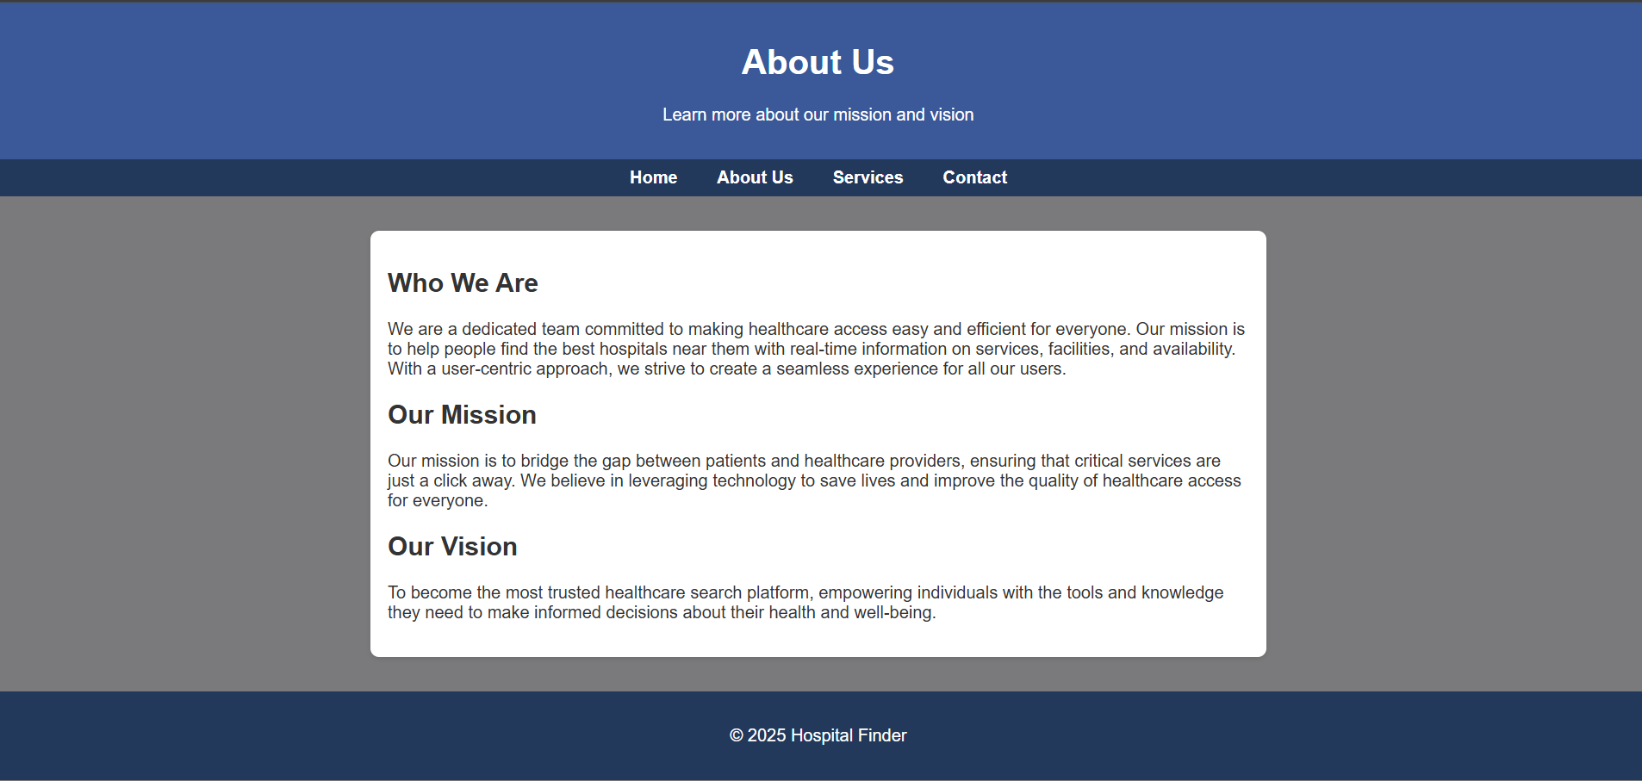

1.2 About Us Page

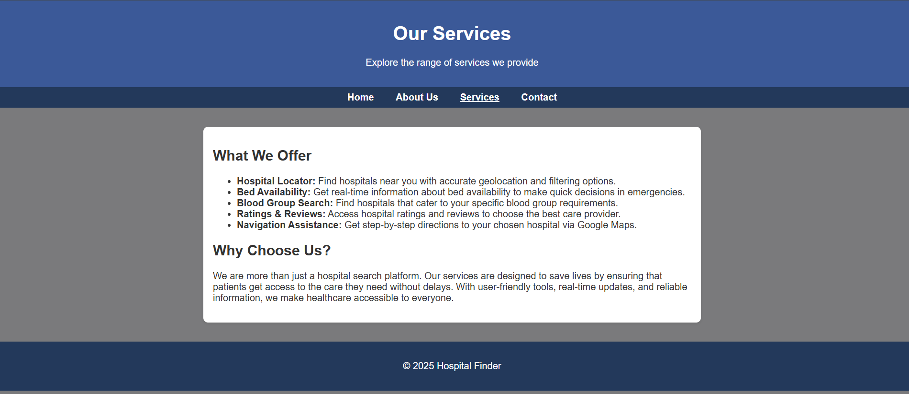

1.3 Services Page



1.4 Contact Us Page

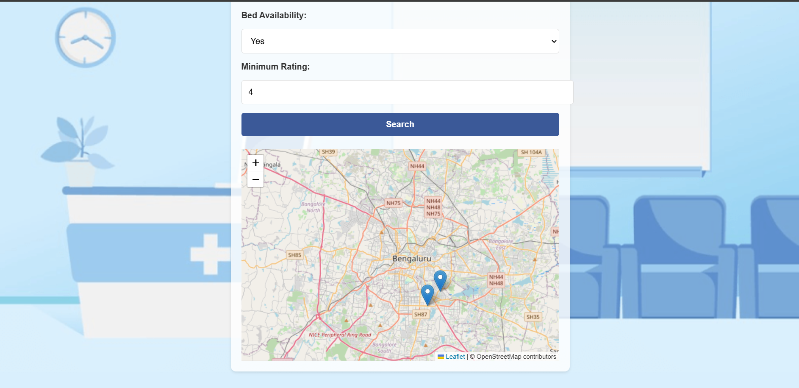

1.5 Nearest Hospital Page

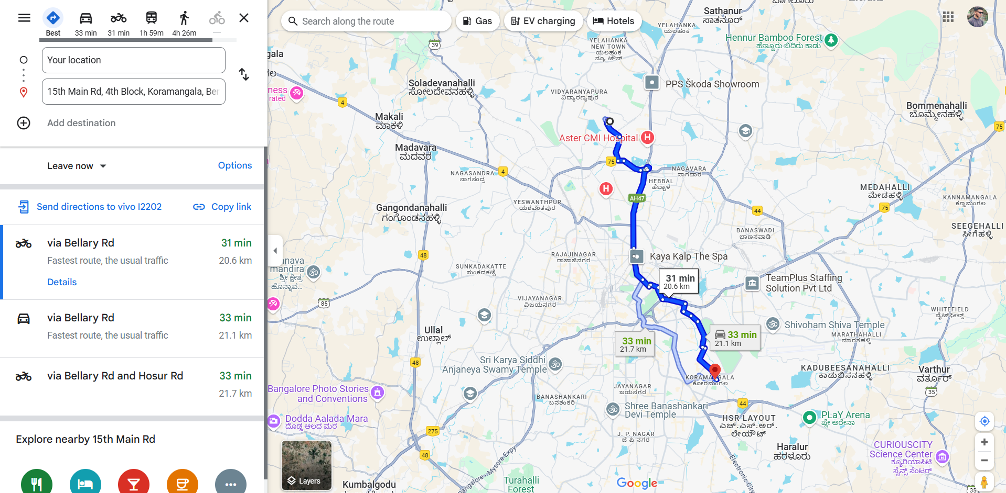

1.6 Geolocation

**APPENDIX-C**

**ENCLOSURES**

**1. Conference Paper Presented Certificates of all students.**

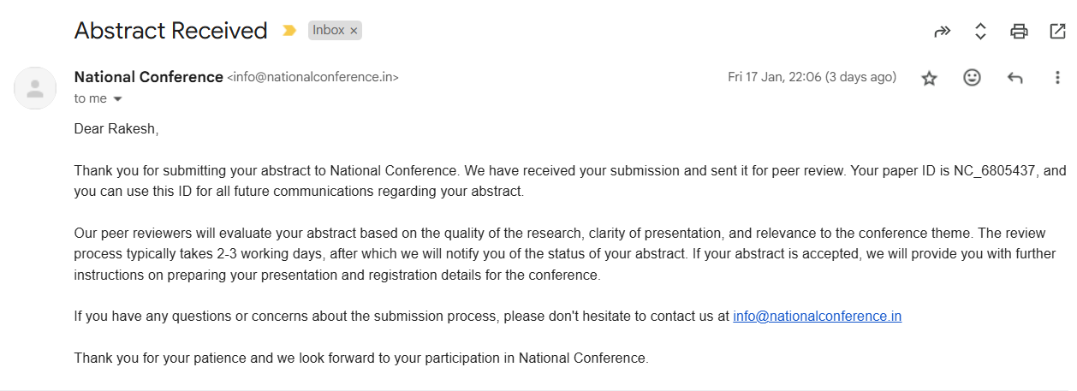

**2. GitHub Link**

**https://github.com/kushw-cloud/Hospital_Finder/**

**3. Similarity Index / Plagiarism Check report clearly showing the Percentage (%). No need for a page-wise explanation.**

**4.Details of mapping the project with the Sustainable Development Goals (SDGs).**



#### 1. Good Health and Well-Being (SDG 3)

The hospital finder system directly supports Good Health and Well-Being by improving access to healthcare services. By helping users quickly find hospitals that meet their needs based on proximity, medical requirements, and real-time data, it facilitates timely medical interventions, especially in emergencies. This access to healthcare can lead to better health outcomes and quicker recovery times, which are crucial in managing both critical and non-critical health situations.

#### 2. Reduced Inequality (SDG 10)

#### The system promotes Reduced Inequality by making healthcare more accessible, especially for individuals in remote or underserved areas. For people with limited resources or knowledge of local healthcare facilities, the hospital finder bridges this gap, ensuring everyone has the opportunity to receive necessary medical care. By offering personalized recommendations based on medical needs, it ensures that users from diverse backgrounds can find the best healthcare options available to them.

#### 3. Industry, Innovation, and Infrastructure (SDG 9)

The project aligns with Industry, Innovation, and Infrastructure by utilizing modern technologies like geolocation and real-time data APIs to improve healthcare service delivery. This promotes innovation in the healthcare sector, encouraging the adoption of digital tools and technologies that streamline the patient-hospital matching process. The system supports the growth of healthcare infrastructure by integrating with external hospital data sources and expanding its reach to new locations.

#### 4. Sustainable Cities and Communities (SDG 11)

The hospital finder contributes to the development of Sustainable Cities and Communities by enhancing healthcare access within urban and rural settings. It ensures that communities, particularly those located in areas with limited healthcare options, can quickly find suitable medical facilities nearby. This feature also supports emergency preparedness, as users can easily locate hospitals in times of crisis, promoting resilience and well-being within communities.